Flathead Lutheran Bible Camp-603 S. Main Kalispell,59901 www.flbc.net

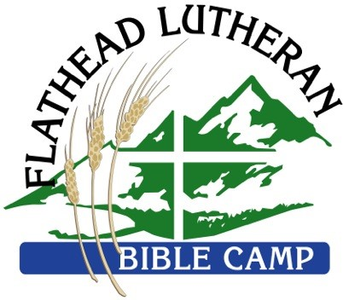2019 Needs List
THANK YOU for your generosity, care, and prayers for the ministry at FLBC!

Arts & Crafts
- Construction Paper
- Acrylic Paint
- Staplers
- Scissors
- Crayons
- Markers
- Pottery Wheel
Cleaning, Maintenance, & Garden
- Large, quality tarps
- Ratchet straps
- Bag-less vacuum cleaners
- Rakes
- Hammers
- Pitchforks
- Trowels
- Shovels
- Commercial-grade washer and dryer
- Duct tape
- Work gloves
- Any and all garden tools
- Hand tools
- Garden hoes
- Lawn mowers
- Snow blower
- Tile or laminate flooring
- Cleaning wipes
Vehicles (in good working order)
- Minivans
- Cars
- 12 Passenger van
- 4-wheel drive truck
- Small 2-wheel drive trucks

First Aid Supplies
- Band-Aids
- Gauze
- Wraps
- Alcohol swabs
- Feminine care products
- Hand Sanitizer

Camping/Program
- Fishing lures
- Pedal boats
- Digital camera
- Go-Pro camera
- Kayaks
- Canoes
- Snow Sleds
- Fishing poles
- Thick oven mitts
- Guitars
- Gloves, Hats, boots, coats, snow pants, for children ages 9-13, for our winter school programs
Office Supplies
- SD memory cards
- Micro-SD memory cards
- Tablet PCs or iPads
- Scotch tape
- Postage stamps
Other
- Small refrigerators (dorm-size)
- TP!
- Large chest freezer
- Regular size refrigerator
- Pressure Washer

